COMPARABLE & COMPARATOR:

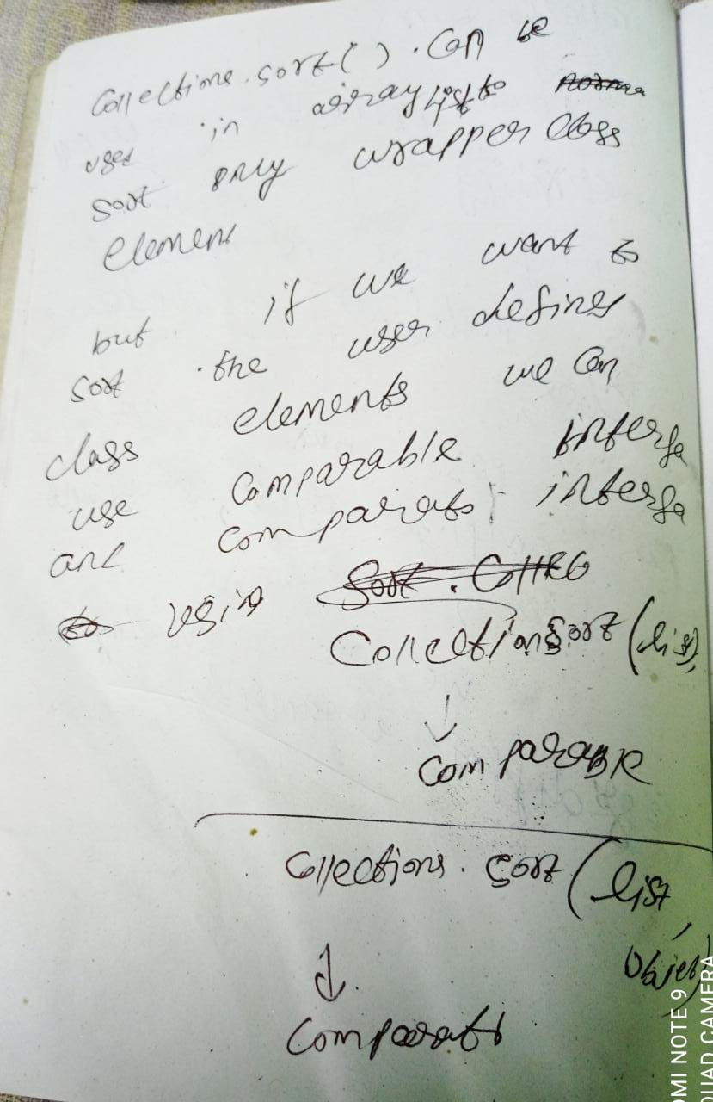
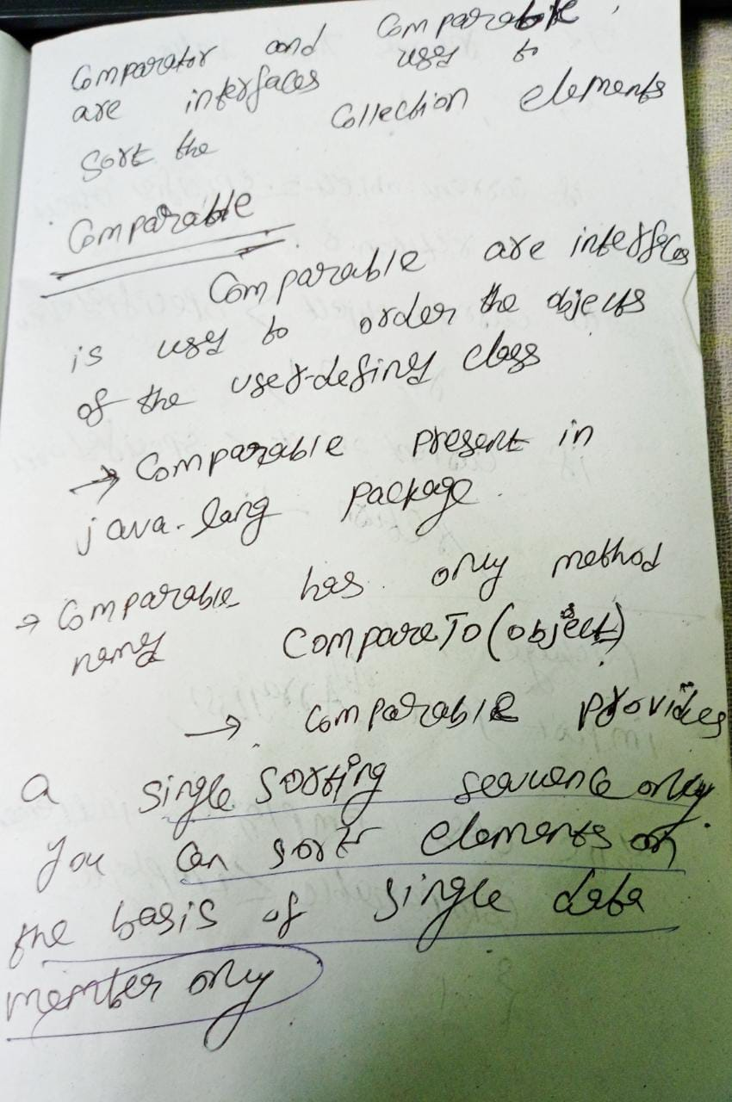
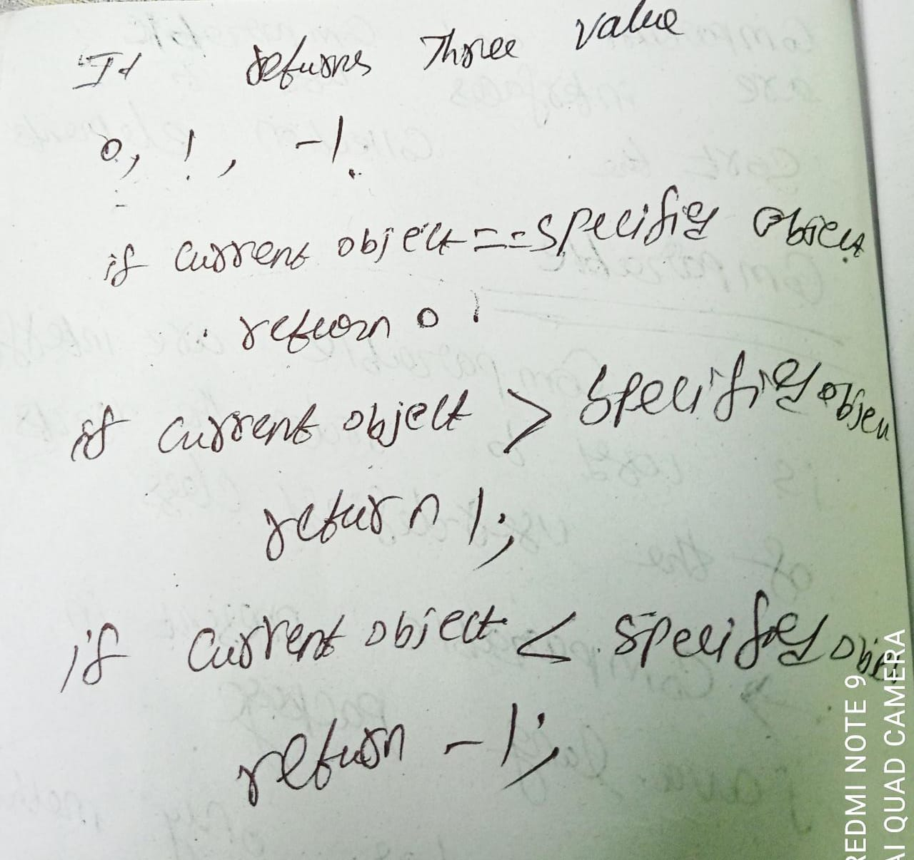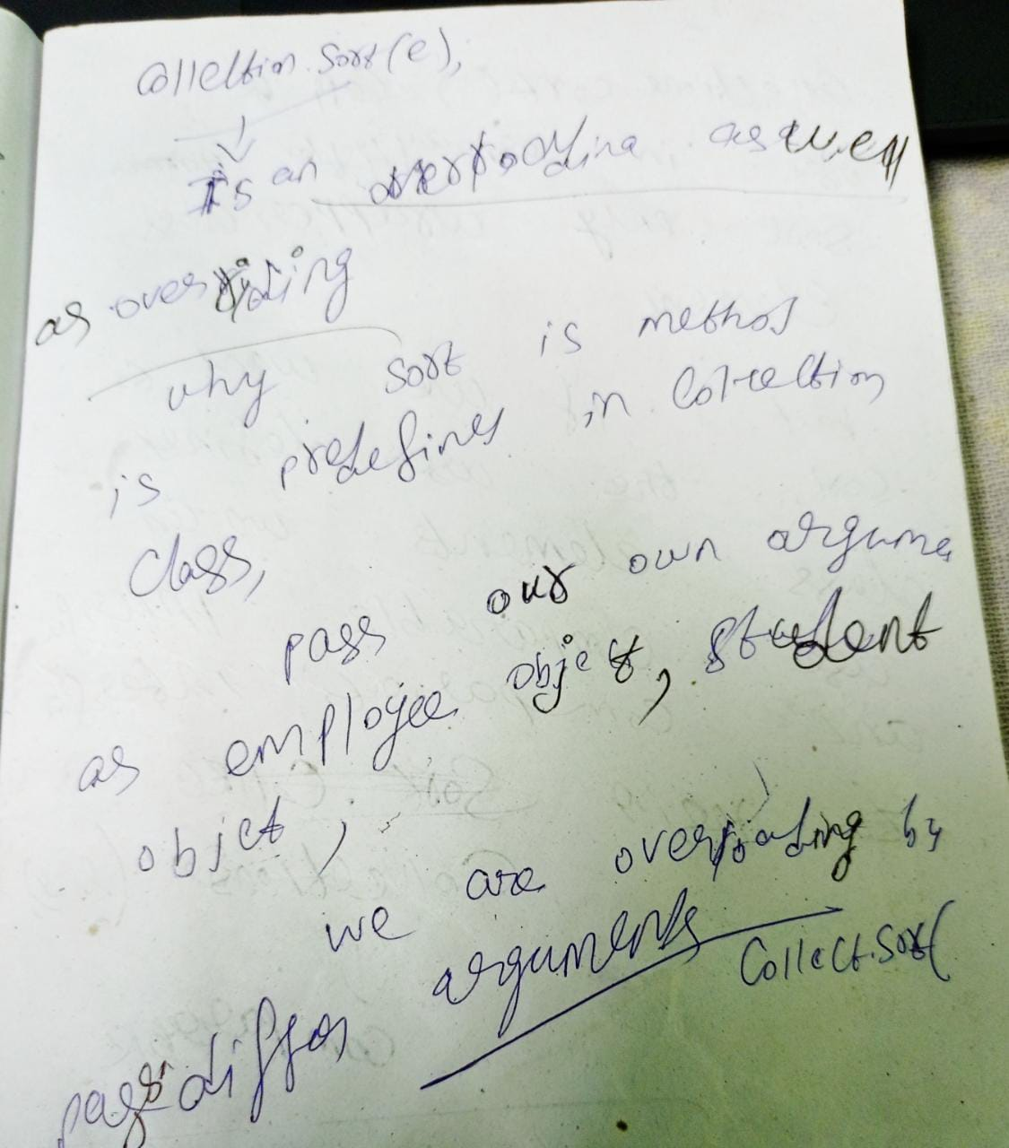

Comparable Interface for Sorting

EXAMPLE 1:
package pack1;
import java.util.ArrayList;
import java.util.Collections;
public class Employee implements
Comparable<Employee>{
int id;
String name;
int age;
Employee(int id,String name,int age){
this.id = id;
this.name = name;
this.age = age;
}
public int getAge() {
return age;
}
public String toString() {
String s;
s="Number:"+id+" "+"Name:"+name+" "+"Age:"+age;
return s;
}
public int compareTo(Employee e)
{
if(age == e.getAge())
return 0;
else if(age >e.getAge())
return 1;
else
return -1;
}

public static void main(String[] args) {
ArrayList<Employee> e = new ArrayList<Employee>();
e.add(new Employee(456,"A",23));
e.add(new Employee(123,"B",22));
e.add(new Employee(345,"C",18));
Collections.sort(e);
for(Employee i:e) {
System.out.println(i);
}
}
}

Comparator Interface for Sorting

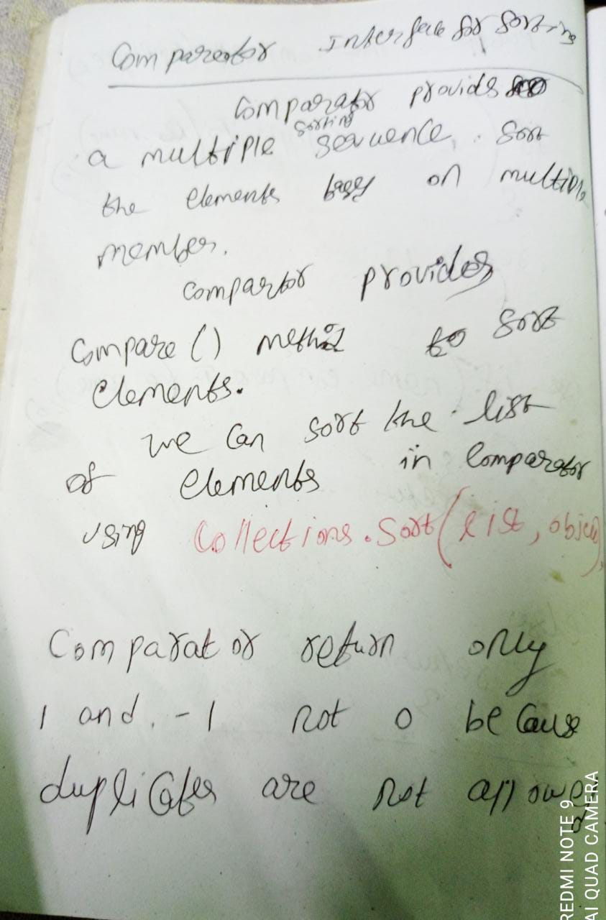

Example 1:

package pack1;

import java.util.*;
public class Student
{
int rollno;
String name, address;

public Student(int rollno, String name, String address){
this.rollno = rollno;
this.name = name;
this.address = address;
}

public String toString(){
return this.rollno + " " + this.name +
" " + this.address;
}
public static void main (String[] args)
{
ArrayList<Student>ar = new ArrayList<Student>();
ar.add(new Student(111, "bbbb", "london"));
ar.add(new Student(131, "aaaa", "nyc"));
ar.add(new Student(121, "cccc", "jaipur"));
ar.add(new Student(121, "dddd", "Dwraka Thirumala"));
ar.add(new Student(111, "kkkkk", "BapatlaBeach"));
System.out.println("Unsorted");
for (int i=0; i<ar.size(); i++)
System.out.println(ar.get(i));
Sortbyroll ob = new Sortbyroll();
Collections.sort(ar, ob);
System.out.println("\nSorted by rollno");
for (int i=0; i<ar.size(); i++)
System.out.println(ar.get(i));

System.out.println("\nSorted by name");
Sortbyname ob1 = new Sortbyname();
Collections.sort(ar, ob1);
for (int i=0; i<ar.size(); i++)
System.out.println(ar.get(i));
}
}
class Sortbyroll implements Comparator<Student>
{
public int compare(Student a, Student b)
{
if(a.rollno<b.rollno)
return 1;
else
return -1;
}
}

class Sortbyname implements Comparator<Student>{
public int compare(Student a, Student b){
if(a.name.compareTo(b.name)>0)
return 1;
else
return -1;
}
}

Example 2:

Draw a class diagram and develop the logic for the following scenario.consider the class cuboid with length, breadth and height as a private attributes.code the parameterized constructor and to string()method.Develop main () method that stores data of cuboid as a collection and must be menu driven with the following operations:1.Add new cuboid 2. Sort by length 3. Sort by area[Hint:Area of cuboid is length*breadth*height]
package p1;

import java.util.ArrayList;
import java.util.Collections;
import java.util.Comparator;
import java.util.Scanner;
public class CuboidDemo{
private int l,b,h;
public CuboidDemo(int l,int b,int h)
{
this.l=l;
this.b=b;
this.h=h;
}
public int getL()
{
return l;
}
public int getH()
{
return h;
}
public int getB()
{
return b;
}
public int getArea()
{
return l*b*h;
}
public String toString()
{
String str=String.format("%d%d%d%d",getL(),getH(),getB(),getArea());
return str;

}
public static void main(String[] args) {
Scanner sc=new Scanner(System.in);
ArrayList<CuboidDemo> li=new ArrayList<CuboidDemo>();
while(true)
{
System.out.println("menu driven");
System.out.println("1.add new cuboid");
System.out.println("2.dispaly all");
System.out.println("3.sort by length");
System.out.println("4.sort by area");
System.out.println("5.exit");
int ch=sc.nextInt();
switch(ch)
{
case 1:System.out.println("enter length breafth height");
CuboidDemo c=new CuboidDemo(sc.nextInt(),sc.nextInt(),sc.nextInt());
li.add(c);
break;
case 2:for(int i=0;i<li.size();i++)
{
System.out.println(li.get(i));
}
break;
case 3:
sortbylength obj=new sortbylength();
Collections.sort(li,obj);
for(int i=0;i<li.size();i++)
{
System.out.println(li.get(i));
}
break;

case 4:
Sortbyarea obj1=new Sortbyarea();
Collections.sort(li,obj1);
for(int i=0;i<li.size();i++)
{
System.out.println(li.get(i));
}
break;

case 5: System.exit(0);
break;
}
}
}
}
class sortbylength implements Comparator<CuboidDemo>
{
public int compare(CuboidDemo o1, CuboidDemo o2)
{
if(o1.getL()>o2.getL())
{
return 1;
}
else
{
return -1;
}
}
}
class Sortbyarea implements Comparator<CuboidDemo>
{
public int compare(CuboidDemo o1, CuboidDemo o2) {
if(o1.getL()>o2.getL())
return 1;

else
return -1;
}

}

